 TVP's World-Best Solar Thermal Panel Certified And Proven

**For Immediate Release Contact**

Jonathan Koifman [koifman@tvpsolar.com](mailto:koifman@tvpsolar.com)

[www.tvpsolar.com](http://www.tvpsolar.com)

* **Int’l Certification**: best efficiency verified under Solar Keymark up to 200°C
* **Commercial Validation**: massive yearly thermal energy supply cuts client operating costs
* **The Future Of Energy**: solar thermal proven to beat traditional fuel prices

**Geneva, Switzerland** – TVP Solar announces the one-year study of its solar thermal panels at a live client site in Kuwait. The results prove TVP’s best-in-class performance operating up to 200°C as recently certified by Din Certco Solar Keymark. The solar field in Kuwait produces a massive amount of thermal energy – 750 kWh/m²/year – with a peak efficiency of 57%, validating certification values.

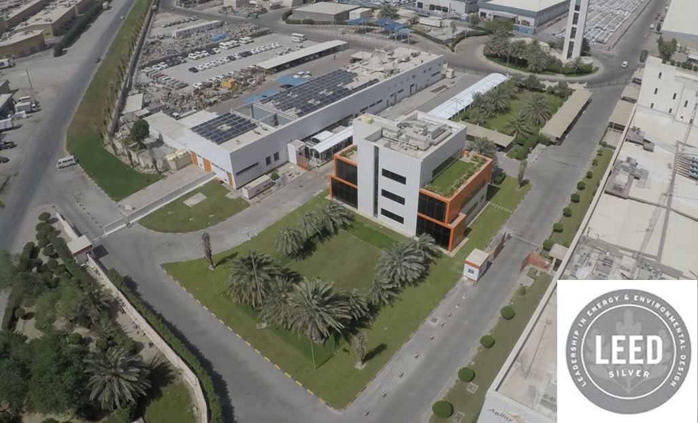

“TVP has proven itself a game-changer,” exclaimed Mr. Piero Abbate, TVP’s CEO. “Our super-performing panels predictably deliver massive thermal energy for the most energy-consuming applications, even in harsh environments like the Gulf.” The panels can be applied to industrial process heat, desalination, and air conditioning.

The solar field delivered up to 180°C to directly drive a double-effect absorption chiller and supply air conditioning to the new Agility Headquarters in Sulaibiya, Kuwait. Over 365 days the system ran automatically and unattended with 98% reliability, showing a mere 8% of efficiency loss due to soiling effect; this was achieved without a single day of panel cleaning!

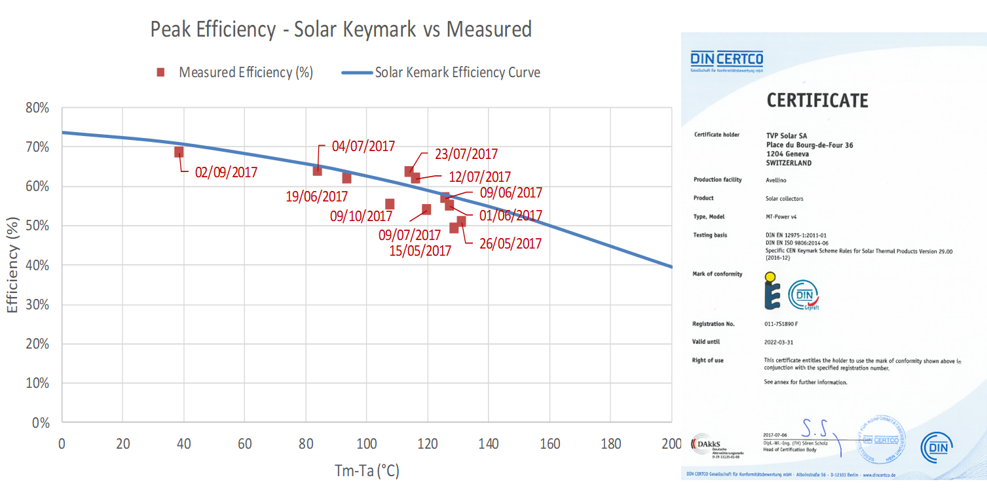

The TVP solar-driven cooling system contributes 73% of the points for the new building’s LEED certification. Operating from 10am to 3pm (on average per day), with ambient temperatures up to 62°C, solar thermal supplied 70% of the daily cooling load, matching the peak load.



Alternative Energy Solutions (AES) CEO Mr. Stephen Lubrano stated: “We are extremely proud to be the first adopter of this revolutionary solution in Kuwait. The solution is perfectly in-line with our parent company’s vision of innovation and social responsibility.” He went on to add that, “TVP economically and efficiently cuts OPEX, meets Agility’s sustainability objectives, and is a key component of the new headquarters’ LEED certification.”

Email [info@tvpsolar.com](mailto:info@tvpsolar.com) for more information and see how solar thermal can benefit you now.

**### ENDS ####**

**About TVP Solar:**

**TVP Solar SA** is a Swiss company which designs, develops, manufactures and markets innovative high-vacuum mirrorless solar thermal collectors based on patented technology. A game-changer for the thermal industry, solar is now a new paradigm in energy supply, beating liquid fuels with a cheaper, carbon-free alternative. In volume production since 2017 TVP high-vacuum products have been installed across 9 countries and 3 continents, cutting OPEX, boosting sustainability, and securing energy supply worldwide.

For more information please visit: [www.tvpsolar.com](http://www.tvpsolar.com)

**Contact person:** Jonathan Koifman

**Contact details:** +41 22 534 9087 [Koifman@tvpsolar.com](mailto:Koifman@tvpsolar.com)

**About Alternative Energy Solutions:**

**AES** is a wholly owned subsidiary of Agility, a company that brings efficiency to supply chains in some of the globe’s most challenging environments, offering unmatched personal service, a global footprint and customized capabilities in developed and developing economies alike. Agility is one of the world’s leading providers of integrated logistics. Agility is a publicly traded company with more than $4.1 billion in revenue and more than 22,000 employees in over 500 offices across 100 countries. Agility’s core commercial business, Global Integrated Logistics (GIL), provides supply chain solutions to meet traditional and complex customer needs. GIL offers air, ocean and road freight forwarding, warehousing, distribution, and specialized services in project logistics, fairs and events, and chemicals. Agility’s Infrastructure group of companies manages industrial real estate and offers logistics-related services, including e-government customs optimization and consulting, waste management and recycling, aviation and ground-handling services, support to governments and ministries of defense, remote infrastructure and life support.

For more information about Agility, visit [agility.com](http://www.agility.com/)

**Contact person:** Stephen Lubrano

**Contact details:** +965 2498 1810 [SLubrano@alenesol.com](mailto:SLubrano@alenesol.com)